
SRM Institute of Science and Technology
Mode of Exam
OFFLINE
College of Engineering and Technology
School of Computing
(Common to all Branches)
DEPARTMENT OF COMPUTING TECHNOLOGIES
SRM Nagar, Kattankulathur – 603203, Chengalpattu District, Tamilnadu
Academic Year: 2023-24 (ODD)
Test: CLAT3 Date: 8.11.2023
Course Code & Title: 21CSS201T / COA Duration: 100 minutes
Year & Sem: II & III SET A Max. Marks: 50
Course Articulation Matrix:
Course Learning Outcomes (CLO) | At the end of this course, learners will be able to: | PO 1 | PO 2 | PO 3 | PO 4 | PO 5 | PO 6 | PO 7 | PO 8 | PO 9 | PO 10 | PO 11 | PO  12
CO-4 | Analyze concepts of parallelism and multi-core processors | H | - | - | - | - | - | - | - | - | - | - | -
CO-5 | Classify the memory technologies, input-output systems and evaluate the performance of memory system | H | M | - | - | - | - | - | - | - | - | - | -

Part – A
Instructions: Answer all (10 x 1 = 10 Marks)

Q. No | Question | Marks | BL | CO | PO | PI Code
1. | Pipelining increases ____________ of the processor  - Throughput  - Latency  - Storage  - Predictivity | 1 | 1 | 4 | 1.3 | 1.3.1
2 | operand forwarding method does the following to overcome data dependencies  - Introduce NULL instructions  - Result of the instruction is written to the temporary register  - Result of one instruction is directly sent to the next instruction for execution  - Blocking the execution of instructions | 1 | 2 | 4 | 1.3 | 1.3.1
3 | For a four-stage pipelining, the initial instruction requires _____ cycle for execution completion?  - 2  - 4  - 3  - 1 | 1 | 1 | 4 | 1.3 | 1.3.1
4 | When the data operands are not available then it is called ___  - Data hazard  - Structural hazard  - Control hazard  - Instruction hazard | 1 | 1 | 4 | 1.3 | 1.3.1
5 | When the branch is actually not taken the state moves from ST to ____.  - SNT  - LT  - LNT  - ST | 1 | 1 | 4 | 1.3 | 1.3.1
6 | Which type of parallelism involves breaking down a program into smaller tasks that can be executed concurrently?  - Instruction-level parallelism  - Data-level parallelism  - Task-level parallelism  - Pipeline parallelism | 1 | 1 | 5 | 1 | 2.1.2
7 | What is the primary advantage of MIMD architecture compared to SISD architecture?  A. Lower cost  B. Simplicity of programming  C. Higher processing power for parallel tasks  D. Energy efficiency | 1 | 1 | 5 | 1 | 2.1.2
8 | Which part of an ARM instruction specifies the operation to be performed?  A. Opcode  B. Data register  C. Memory address  D. Condition code | 1 | 1 | 5 | 1 | 2.1.2
9 | Which part of an ARM-based system typically handles I/O operations and device communication?  - Memory unit  - Arithmetic logic unit (ALU)  - Input unit  - Peripheral interface or controller | 1 | 1 | 5 | 1 | 2.1.2
10 | What is the primary advantage of the Thumb instruction set in ARM7 architecture?  - Greater computational power  - Smaller code size  - Enhanced multimedia capabilities  - Improved memory management | 1 | 1 | 5 | 1 | 2.1.2

Part – B
Instructions: Answer any 4 ( 4 x 4 = 16 Marks)

11 Design a 4-stage instruction pipeline for 3 instructions I1,I2,I3 to be executed. Consider that there are no dependency between the instructions.
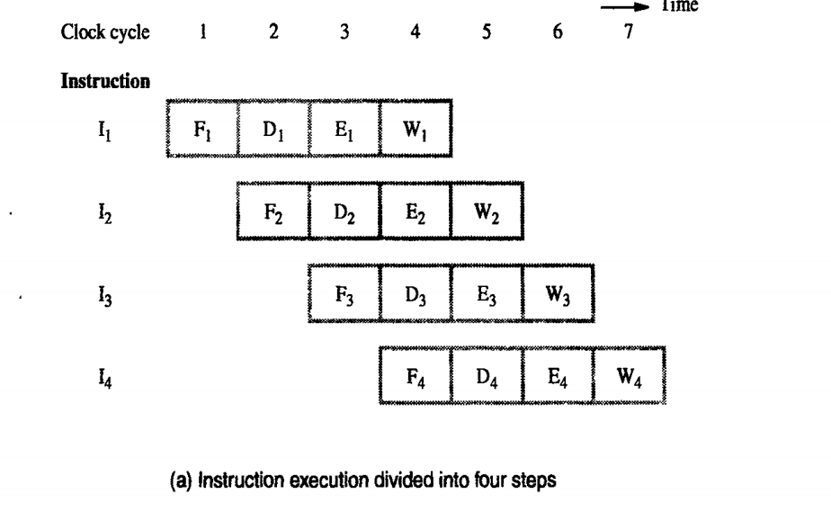

12 Draw and explain the two state diagram for dynamic branch prediction.
- State 1: LT : Branch is likely to be taken
- State 2: LNT : Branch is likely not to be taken
- 1.If the branch is taken,the machine moves to LT. otherwise it remains in state LNT.
- 2.The branch is predicted as taken if the corresponding state machine is in state LT, otherwise it is predicted as not taken
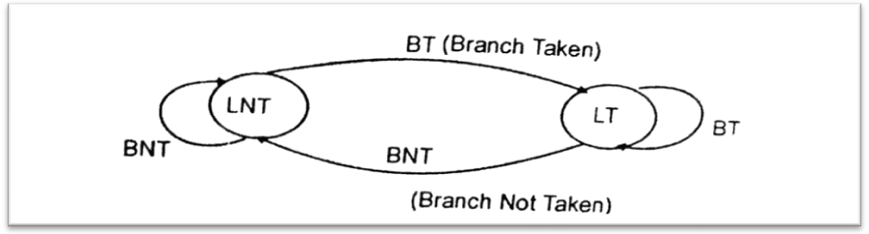

13 Interpret about out of order execution?
- If an optimizing compiler attempts to reorder instruction to avoid stalling the pipeline when branches or data dependencies between successive instructions occur, it must ensure that reordering does not cause a change in the outcome of a computation.
- The dependency introduced by the condition-code flags reduces the flexibility available for the compiler to reorder instructions.
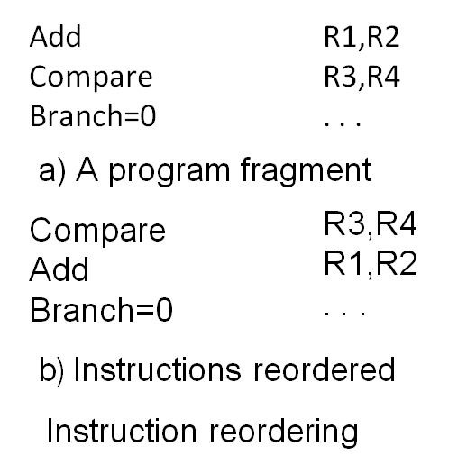

14 Discuss the five step Sequential execution with example
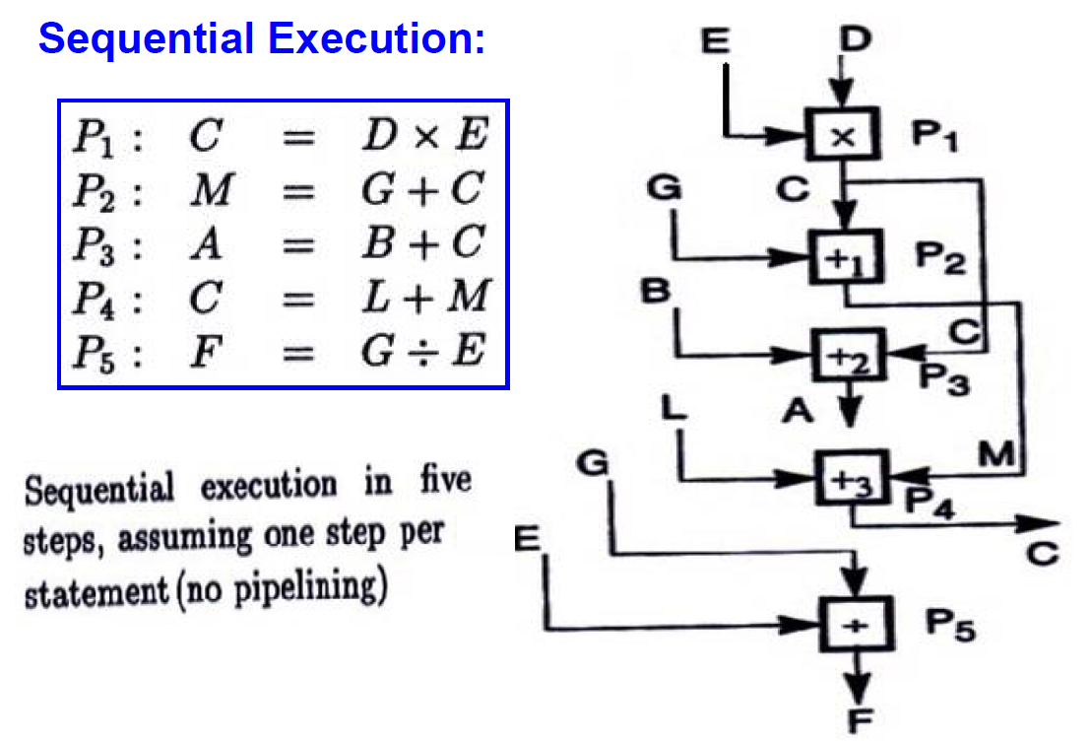

15 Discuss the concepts involved in ILP and how many unit of time to complete the operations
- Instruction level Parallelism (ILP) is a measure of how many operations can be performed in parallel at the same time in a computer.
- Parallel instructions are set of instructions that do not depend on each other to be executed.
- ILP allows the compiler and processor to overlap the execution of multiple instructions or even to change the order in which instructions are executed.
3 operations can be completed in 2 units of time .

PART C
Instructions: Answer all (12 x 2 = 24 Marks)

16. A Arun and Bob are having equal number of apples and it’s count are stored in the register R1 and R2 respectively. Arun collected bob’s apple and store the entire set of apples with him and update its count in R1. Write the complete set of control sequences for the above operation.


OR
16. B Illustrate the scenario where instructional hazard occurs and provide the solution for handling the stall created by conditional branch instruction.
- If Sequence of instruction being executed in two stages pipeline instruction I1 to I3 are stored at consecutive memory address and instruction I2 is a branch instruction.
- If the branch is taken then the PC value is not known till the end of I2.
- Next third instructions are fetched even though they are not required
- Hence they have to be flushed after branch is taken and new set of instruction have to be fetched from the branch address
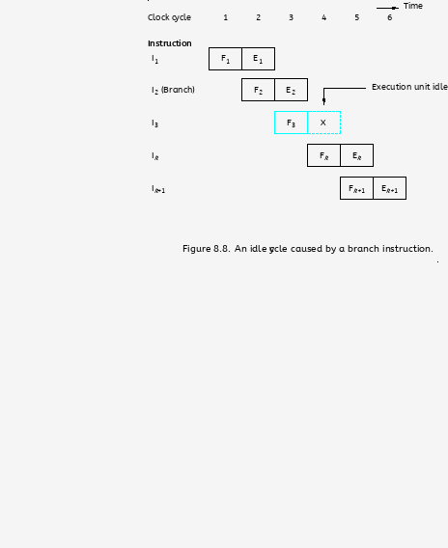
Branch penalty
- The time lost as the result of branch instruction
Reducing the penalty
- The branch penalties can be reduced by proper scheduling using compiler techniques.
- For longer pipeline, the branch penalty may be much higher
- Reducing the branch penalty requires branch target address to be computed earlier in the pipeline
- Instruction fetch unit must have dedicated hardware to identify a branch instruction and compute branch target address as quickly as possible after an instruction is fetched
Instruction prefetching
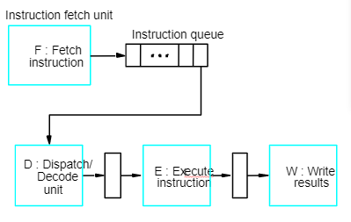

17 A. Explain the various types of Parallelism.
Hardware Parallelism
- Processor parallelism
- Memory parallelism
Software Parallelism
- Sequential execution
- Parallel execution
      - Instruction level parallelism
      - Task-level parallelism
      - Data parallelism
      - Transaction level parallelism

OR
17 B With the evolution of computing, multi-core processors have become a standard in modern computer architectures.
- Define and differentiate between a processor and CPU cores. (4 marks)
The processor is the primary component of a computer that performs most of the processing inside the computer. It interprets computer program instructions and processes data. The CPU acts as the brain of the computer. CPU Cores: A core is a component within the processor. It can read and execute program instructions independently of the other cores. Modern processors can have multiple cores (dual-core, quad-core, etc.), allowing them to read and execute multiple instructions simultaneously, essentially like having multiple processors in a single chip. Differentiation: The primary difference is that while a processor refers to the main computational unit that interprets and executes instructions, a core is a part of this unit, and a processor can have one or more cores. The more cores a processor has, the more tasks it can handle simultaneously. Explain with relevant diagrams.

- Discuss the advantages and potential challenges of multi-core processors compared to single-core processors. (6 marks)
Advantages: Parallel Processing: Multi-core processors can handle multiple tasks simultaneously, leading to better multitasking and parallel processing capabilities. Energy Efficiency: Distributing tasks among multiple cores can be more energy-efficient, as each core can run at a lower speed, reducing heat generation. Performance Boost: For software designed to take advantage of multi-core architectures, significant performance improvements can be observed. Challenges: Software Limitations: Not all software is designed to utilize multiple cores effectively. Some older applications might not benefit from multi-core processors. Diminishing Returns: As the number of cores increases, the performance gains can start to diminish unless software and tasks are perfectly parallelizable. Complexity: Managing multiple cores can introduce complexities in terms of synchronization, data sharing, and the potential for increased cache misses. Explain with relevant diagrams.

c. Explain how software developers might need to adapt their programming techniques to fully utilize the capabilities of multi-core processors. (2 marks)
Software developers need to adopt parallel programming paradigms to leverage multi-core processors effectively. This involves breaking down tasks into smaller sub-tasks that can be executed concurrently. Tools and libraries, such as OpenMP and Threading Building Blocks (TBB), can assist developers in this. Additionally, developers must be aware of potential pitfalls like race conditions and deadlocks, which can arise when multiple cores access shared resources.

